
FACULTY OF ENGINEERING
DIPLOMA ENGINEERING
DEPARTMENT OF COMPUTER ENGINEERING
ADVANCED COMPUTER NETWORK (DE103503)

Unit-3 : Unicast Routing

Introduction–Routing:
When a device has multiple paths to reach a destination, it always selects one path by preferring it over others. This selection process is termed as Routing. Routing is done by special network devices called routers or it can be done by means of software processes. The software based routers have limited functionality and limited scope.
A router is always configured with some default route. A default route tells the router where to forward a packet if there is no route found for specific destination. In case there are multiple path existing to reach the same destination, router can make decision based on the following information:
- Hop Count
- Bandwidth
- Metric
- Prefix-length
- Delay
Routes can be statically configured or dynamically learnt. One route can be configured to be preferred over others.

Unicast routing
Most of the traffic on the internet and intranets known as unicast data or unicast traffic is sent with specified destination. Routing unicast data over the internet is called unicast routing. It is the simplest form of routing because the destination is already known. Hence the router just has to look up the routing table and forward the packet to next hop.
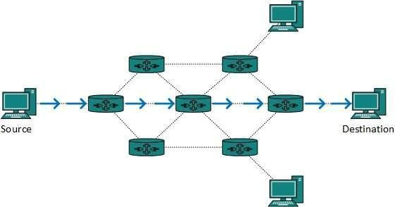

Intra-and Inter-domain Routing
An internet can be so large that one routing protocol cannot handle the task of updating the routing tables of all routers. For this reason, an internet is divided into autonomous systems. An autonomous system (AS) is a group of networks and routers under the authority of a single administration. Routing inside an autonomous system is referred to as intra domain routing. Routing between autonomous systems is referred to as inter domain routing.
Several intra domain and inter domain routing protocols are in use. Two intra domain routing protocols: Distance vector and link state. One inter domain routing protocol: path vector.
Routing Information Protocol (RIP) is an implementation of the distance vector protocol. Open Shortest Path First (OSPF) is an implementation of the link state protocol. Border Gateway Protocol (BGP) is an implementation of the path vector protocol.

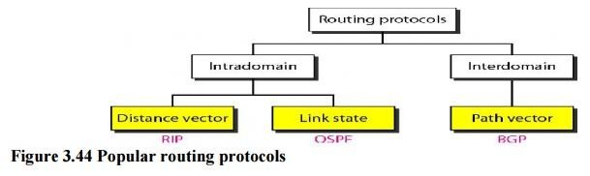

Intra-domain Routing is different from Inter-domain Routing.
Intra domain is any protocol in which Routing algorithm works only within domains on the other hand Inter domain is any protocol in which Routing algorithm works within and between domains.
Let us see the differences between Intra domain and Inter domain:

Routing Algorithms
- Distance Vector Routing

In distance vector routing, the least-cost route between any two nodes is the route with minimum distance. In this protocol, as the name implies, each node maintains a vector (table) of minimum distances to every node. The table at each node also guides the packets to the desired node by showing the next stop in the route (next-hop routing).

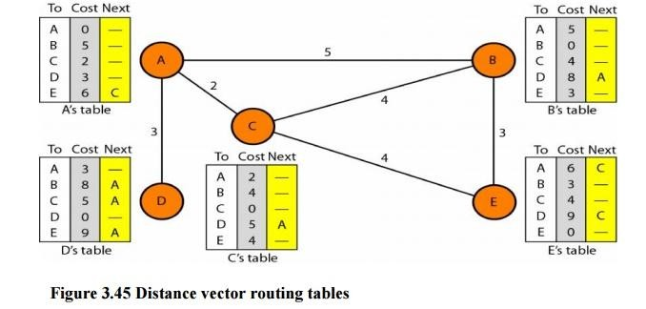

The table for node A shows how we can reach any node from this node. For example, our least cost to reach node E is 6. The route passes through C

Initialization
The tables in Figure 3.45 are stable; each node knows how to reach any other node and the cost. At the beginning, however, this is not the case. Each node can know only the distance between itself and its immediate neighbors, those directly connected to it. So for the moment, we assume that each node can send a message to the immediate neighbors and find the distance between itself and these neighbors. The distance for any entry that is not a neighbor is marked as infinite (unreachable).

Sharing
The whole idea of distance vector routing is the sharing of information between neighbors. Although node A does not know about node E, node C does. So if node C shares its routing table with A, node A can also know how to reach node E. On the other hand, node C does not know how to reach node D, but node A does. If node A shares its routing table with node C, node C also knows how to reach node D. In other words, nodes A and C, as immediate neighbors, can improve their routing tables if they help each other.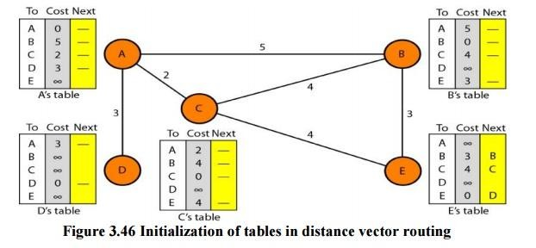

(2) Link State Routing
Link state routing has a different philosophy from that of distance vector routing. In link state routing, if each node in the domain has the entire topology of the domain the list of nodes and links, how they are connected including the type, cost (metric), and condition of the links (up or down)-the node can use Dijkstra's algorithm to build a routing table.

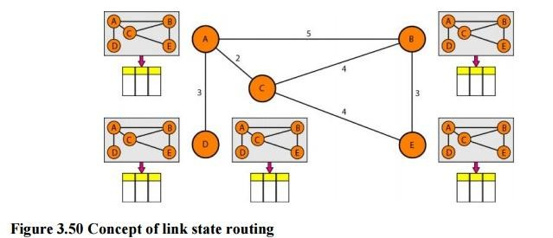
The figure shows a simple domain with five nodes. Each node uses the same topology to create a routing table, but the routing table for each node is unique because the calculations are based on different interpretations of the topology. This is analogous to a city map. While each person may have the same map, each needs to take a different route to reach her specific destination
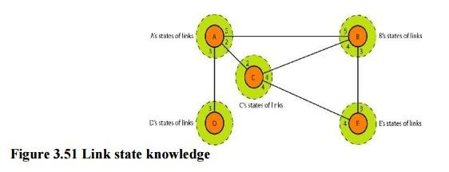
Building Routing Tables:

Types of Links

In OSPF terminology, a connection is called a link .Four types of links have been defined: point-to-point, transient, stub, and virtual.
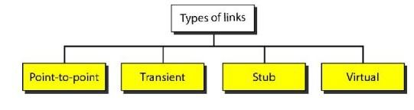

(3)Path Vector Routing
Distance vector and link state routing are both intradomain routing protocols. They can be used inside an autonomous system, but not between autonomous systems. These two protocols are not suitable for interdomain routing mostly because of scalability. Both of these routing protocols become intractable when the domain of operation becomes large. Distance vector routing is subject to instability if there are more than a few hops in the domain of operation. Link state routing needs a huge amount of resources to calculate routing tables. It also creates heavy traffic because of flooding. There is a need for a third routing protocol which we call path vector routing.
Path vector routing proved to be useful for interdomain routing. The principle of path vector routing is similar to that of distance vector routing. In path vector routing, we assume that there is one node in each autonomous system that acts on behalf of the entire autonomous system.

Initialization
At the beginning, each speaker node can know only the reachability of nodes inside its autonomous system

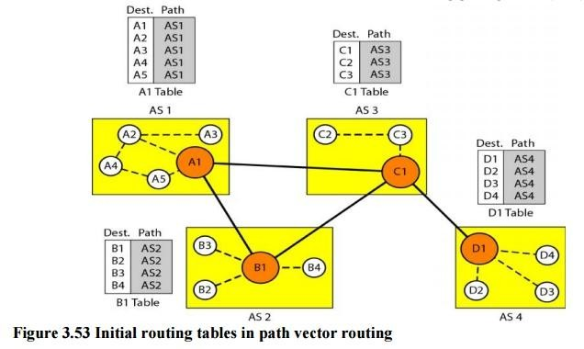
Node Al is the speaker node for AS1, B1 for AS2, C1 for AS3, and Dl for AS4. Node Al creates an initial table that shows Al to A5 are located in ASI and can be reached through it. Node B1 advertises that Bl to B4 are located in AS2 and can be reached through Bl. And so on.

Internet structure:

Computers connected to the internet means that the systems are connected to computers’ worldwide network. Therefore, each machine/device has its own or unique address. Addresses of the internet are in the form “kkk.kkk.kkk.kkk,”where each “kkk”ranges from 0-256. This structure of the internet address is known as an IP address (Internet Protocol). Fig. 1 describes the connection between two computers using the internet. Both systems have unique IP addresses. However, the internet is a unique object between both systems.

RIP Protocol
RIP stands for Routing Information Protocol.

RIP is an intra-domain routing protocol used with in an autonomous system.

Here, intra-domain means routing the packets in a defined domain, for example, web browsing within an institutional area.
To understand the RIP protocol, our main focus is to know the structure of the packet, how many fields it contains, and how these fields determine the routing table.

How is hop count determined?

When the routers ends the packet to the network segment, then it is counted as a single hop.
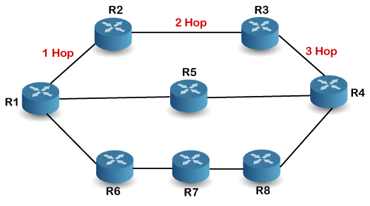

In the above figure, when therouter1 forwardsthepackettotherouter2then it will count as 1 hop count. Similarly, when the router 2 forwards the packet to the router 3 then it will count as 2hop count, and when therouter3 forwards the packet or outer 4,it will countas3 hop count. In the same way, RIP can support maximum up to 15 hops, which means that the 16 routers can be configured in a RIP.

RIP Message Format

Now, we look at the structure of the RIP message format. The message format is used to share information among different routers. The RIP contains the following fields in a message:
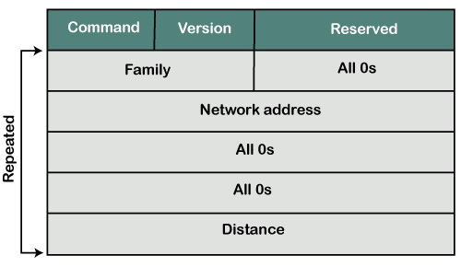
- Command: It is an 8-bit field that is used for request or reply. The value of the request is 1, and the value of the reply is 2.
- Version: Here, version means that which version of the protocol we are using. Suppose we are using the protocol of version1, then we put the 1 in this field.
- Reserved: This is a reserved field , so it is filled with zeroes.
- Family:Itisa16-bitfield.AsweareusingtheTCP/IPfamily,soweput2valueinthis field.
- Network Address: It is defined as 14 bytes field. If we use the IPv4 version, then we use 4bytes, and the other 10 bytes are all zeroes.
- Distance: The distance field specifies the hop count, i.e., the number of hops used to reach the destination.

How does the RIP work?

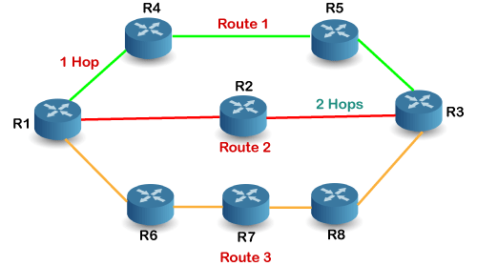

If there are 8 routers in a network where Router 1 wants to send the data to Router 3. If the network is configured with RIP, it will choose the route which has the least number of hops. There are three routes in the above network,
i.e., Route 1, Route2,and Route3.The Route2 contains the least number of hops,

i.e.,2 where Route1 contains3 hops, and Route3 contains4 hops,

soRIPwillchooseRoute2.

Disadvantages of RIP

The following are the disadvantages of RIP:

- In RIP ,the route is chosen based on the hop count metric. If another route of better bandwidth is available, then that route would not be chosen.
- The RIP is a classful routing protocol, so it does not support the VLSM (Variable Length Subnet Mask). The classful routing protocol is a protocol that does not include the subnet mask information in the routing updates.
- RIP supports maximum 15 hops which means that the maximum 16 hops can be configured in a RIP

Advantages of RIP
- It is easy to configure
- It has less complexity

- The CPU utilization is less.

OSPF Protocol

The OSPF stands for Open Shortest Path First. It is a widely used and supported routing protocol.
It is an intra domain protocol, which means that it is used with in an area or a network.
It is an interior gateway protocol that has been designed with in a single autonomous system.
It is based on a link-state routing algorithm in which each router contains the information of every domain, and based on this information, it determines the shortest path.

How does OSPF work?

There are three steps that can explain the working of OSPF:

Step1: The first step is to become OSPF neighbors. The two connecting routers running OSPF on the same link creates a neighbor relationship.
Step 2: The second step is to exchange database information. After becoming the neighbors, the two routers exchange the LSDB information with each other.
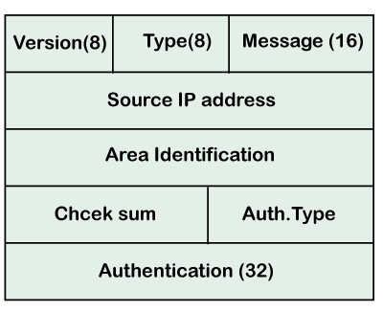
Step 3: The third step is to choose the best route. Once the LSDB information has been exchanged with each other, the router chooses the best route to be added to a routing table based on the calculation of SPF.

  - Version: It is an 8-bit field that specifies the OSPF protocol version.
  - Type: It is an8-bit field. It specifies the type of the OSPF packet.
  - Message: It is a 16-bit field that defines the total length of the message, including the header. Therefore, the total length is equal to the sum of the length of the message and header.
  - Source IP address: It defines the address from which the packets are sent. It is a sending routing IP address.
  - Area identification: It defines the area with in which the routing takes place.
  - Check sum: It is used for error correction and error detection.
  - Authentication type: There are two types of authentication, i.e., 0 and 1. Here, 0 means for none that specifies no authentication is available and 1 means for pwd that specifies the password-based authentication.
  - Authentication: It is a 32-bit field that contains the actual value of the authentication data.

Border Gateway Protocol
It is an interdomain routing protocol, and it uses the path-vector routing. It is a gateway protocol that is used to exchange routing information among the autonomous system on the internet.
As we know that Border Gateway Protocol works on different autonomous systems, so we should know the history of BGP, types of autonomous systems, etc. BGP Packet Format

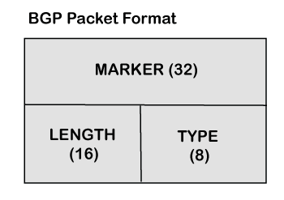

- Marker:Itisa32-bitfieldwhichisusedfortheauthenticationpurpose.
- Length:Itisa16-bitfieldthatdefinesthetotallengthofthemessage,includingthe header.
- Type:Itisan8-bitfieldthatdefinesthetypeofthepacket.

